Exp 9. Create a Snapshot of a VM and Test it by loading the Previous Version/Cloned VM using virtual

box.

Step 1: Open the virtual box and select the installed OSI model.

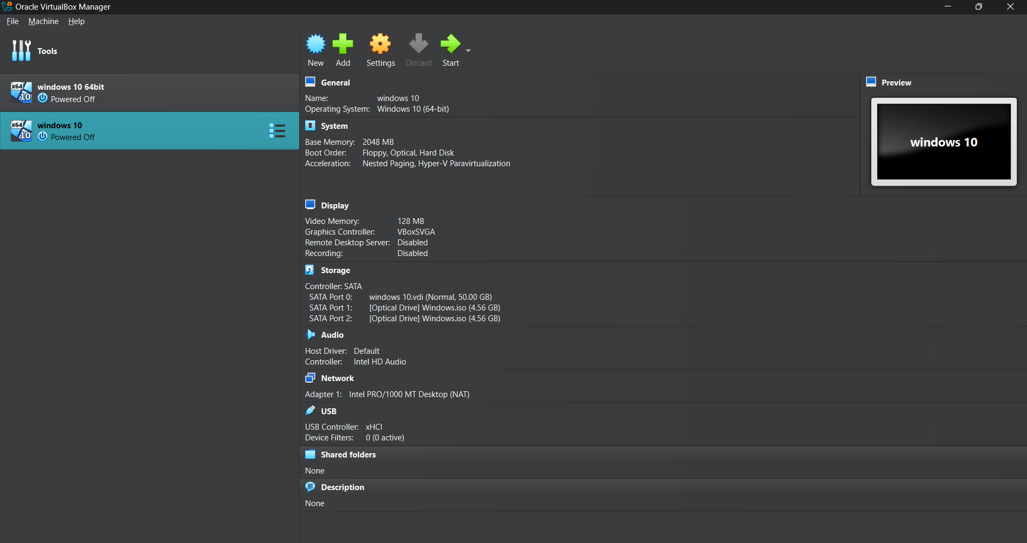

Step 2: click on next to the left panel and click on snapshot .

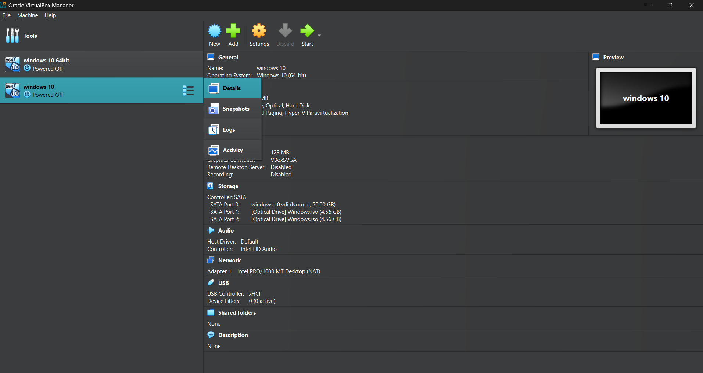

Step 3: Click on take snapshot 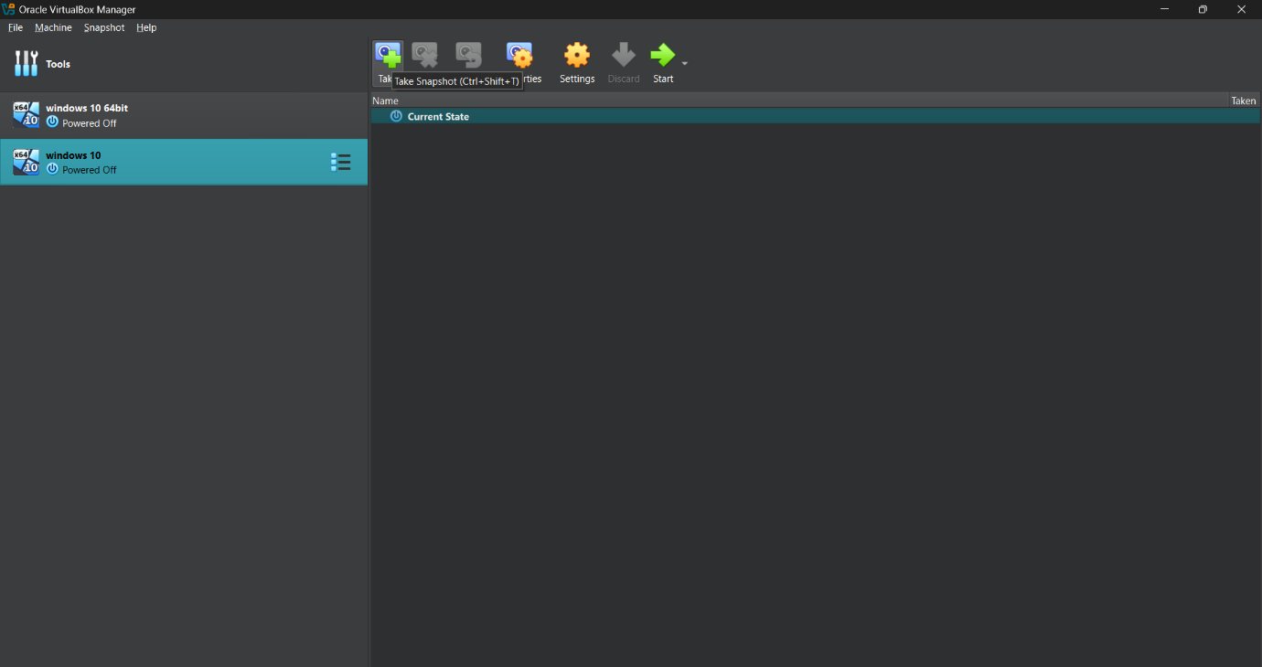

Step 4: capture the snapshot and restart the virtual machine

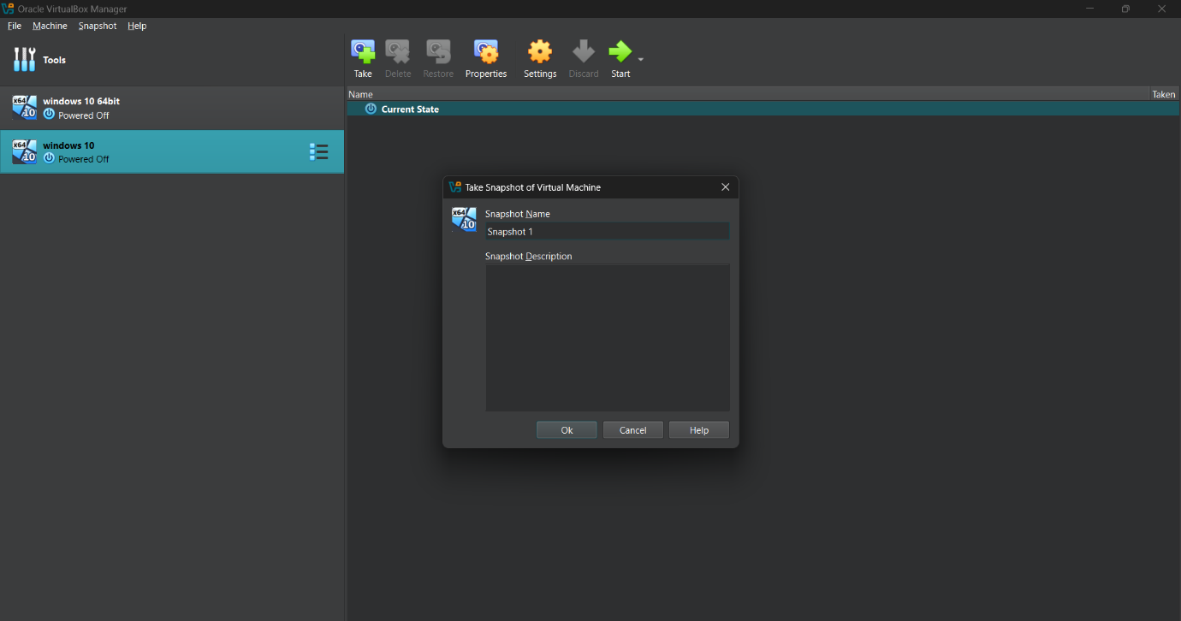

Step 5:

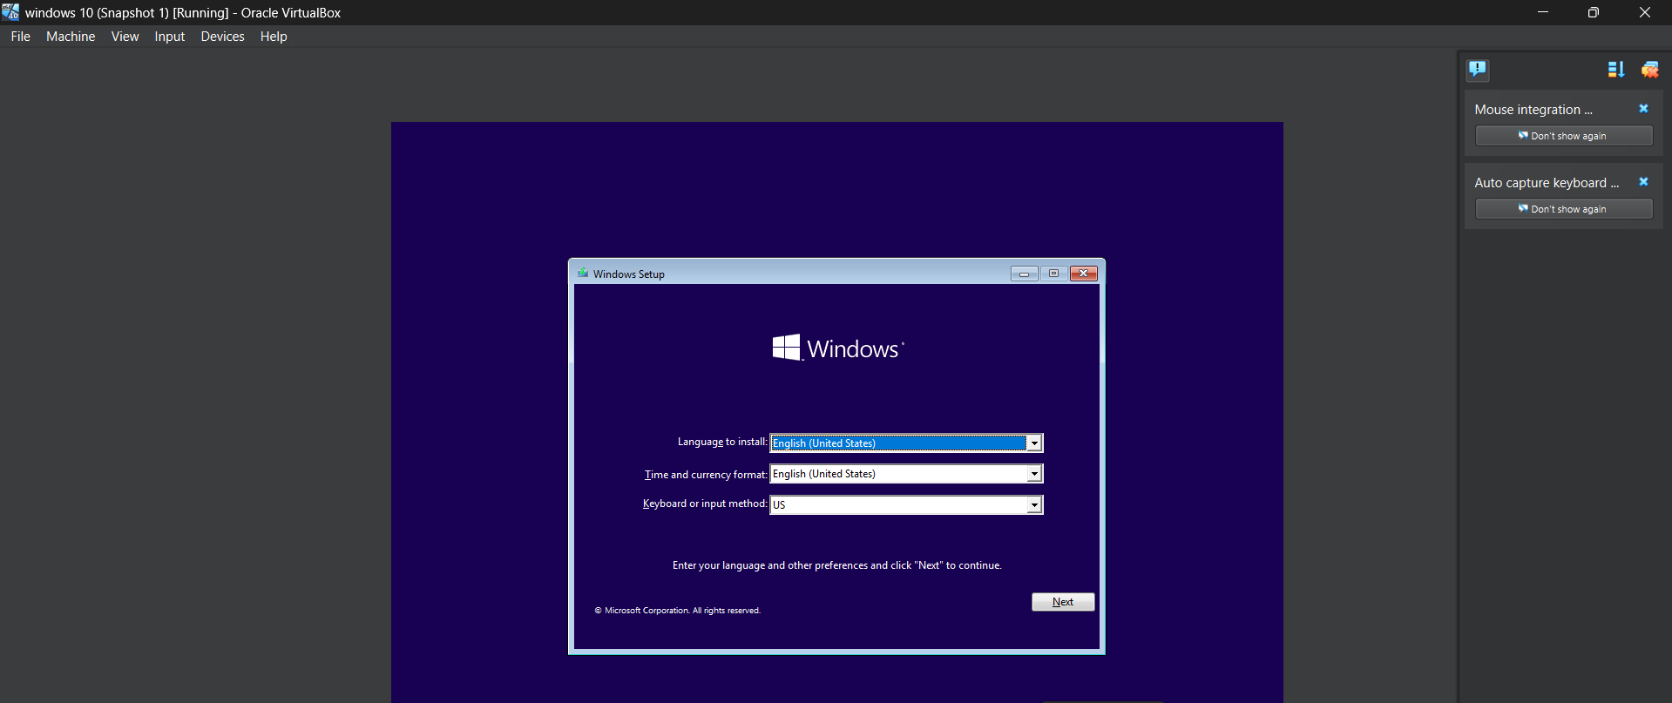

Step 6:

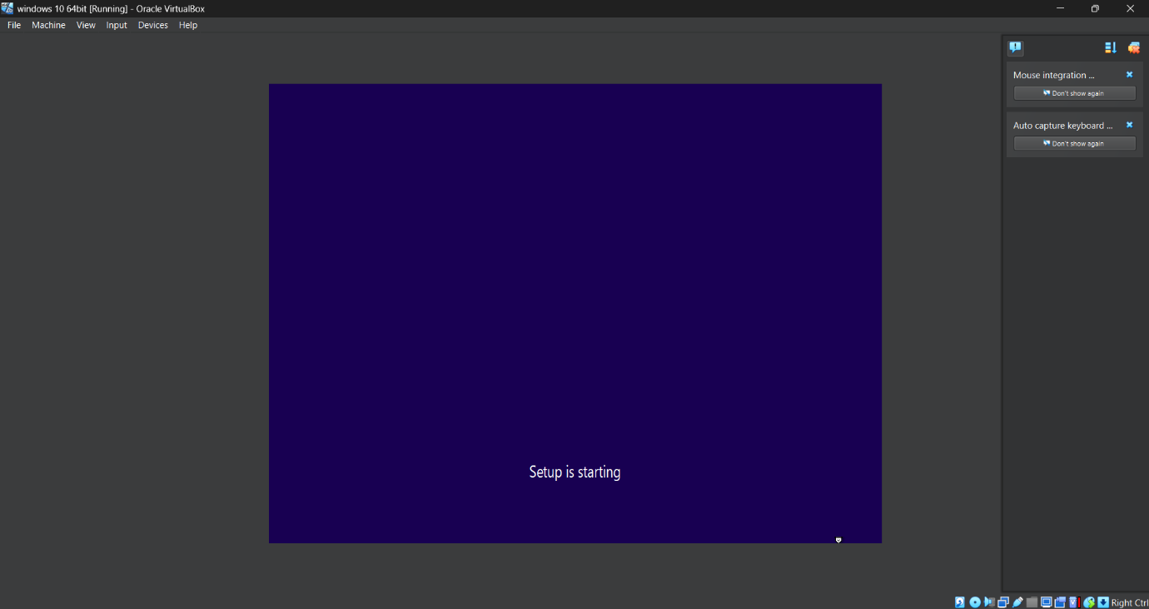

Step 7:

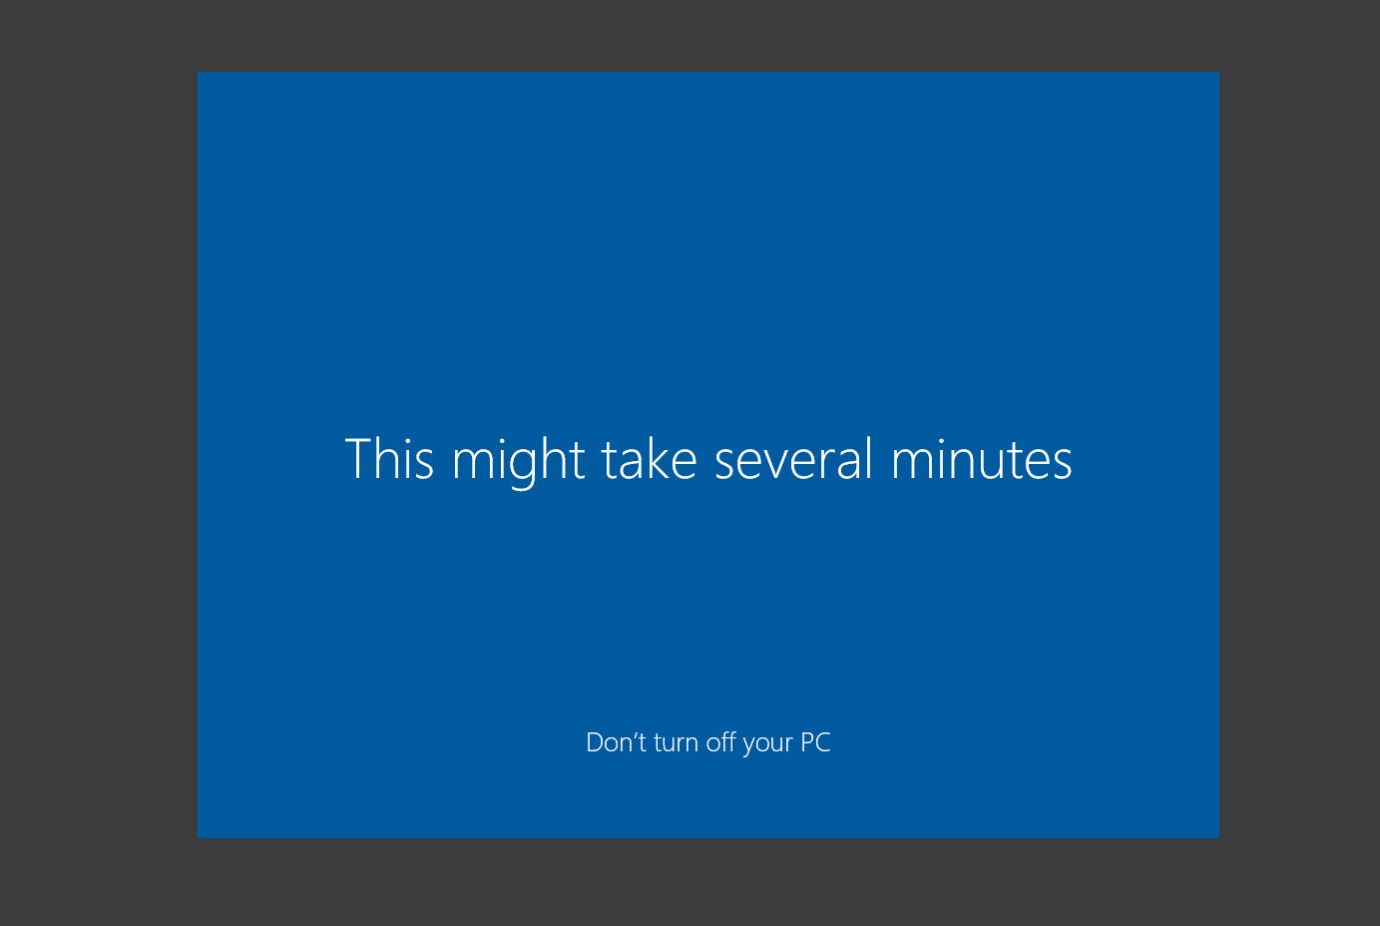

Step 8:

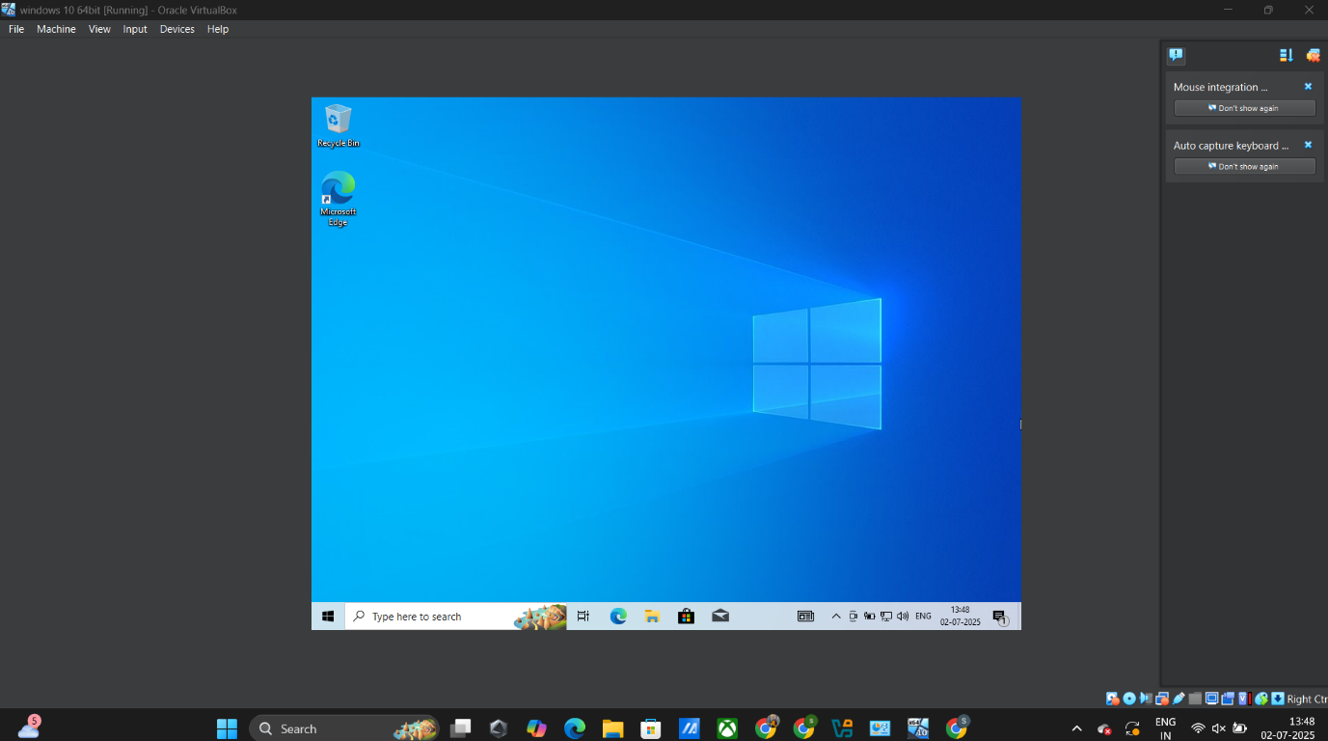

Step 9: After capturing snapshot the current status is changed.

